2012
HSC TRIAL
EXAMINATION PAPER
Modern History

General Instructions  - Reading Time – 5 minutes  - Working Time – 3 hours  - Write using black or blue pen  - A source booklet is provided at  the back of this paper  - Write your student number at  the bottom of this page | Total Marks - 100  Section I Pages 2–7  25 marks  This section has two parts, Part A and Part B  - Allow about 45 minutes for this section  Part A – 15 marks  - Attempt Questions 1–8  Part B – 10 marks  - Attempt Question 9  Section II Pages 8–10  25 marks  - Attempt ONE question from Questions 10–18  - Allow about 45 minutes for this section  Section III Page 11  25 marks  - Attempt BOTH parts of Question 19  - Allow about 45 minutes for this section  Section IV Pages 12–13  25 marks  - Attempt ONE question from Questions 20–26  - Allow about 45 minutes for this section

THIS PAPER CANNOT BE RELEASED IN PUBLIC UNTIL AFTER 24TH AUGUST 2012
This paper is used with the understanding that it has a Security Period. ©Total Education Centre

Student Number: __________________________________ Class:____________
Section I — World War I 1914–1919
25 Marks
Allow about 45 minutes for this section

Part A – 15 marks
Attempt Questions 1–8
Allow about 25 minutes for this part

For multiple-choice questions, fill in the response oval next to the alternative that best answers the question.

For other questions, answer in the spaces provided. These spaces provide guidance for the expected length of response.

1 | What is the purpose of Source A? |  | 1
 | (A) | To establish a memorial for Edith Cavell
 | (B) | To remind the public of the importance of nurses during war time
 | (C) | To remind the public of the actions soldiers are forced to take during war time
 | (D) | To create an image of the Germans as brutal and inhumane

2 | Use Source A and your own knowledge to answer this question.  Give THREE reasons for the use of propaganda in Britain and/or Germany during WWI. | 3

3 | Read Statements 1 and 2, then select the correct answer.  Statement 1. Source B proves that anti-German propaganda in Britain had failed.  Statement 2. According to Source B, the Christmas truce made the soldiers  reluctant to kill their enemy. |  | 1
 | (A) | Both statements are correct.
 | (B) | Neither statement is correct.
 | (C) | Only Statement 1 is correct.
 | (D) | Only Statement 2 is correct.

4 | What is Source C is evidence of? |  | 1
 | (A) | The role of artillery during WWI
 | (B) | The defensive strategy of the Allies during WWI
 | (C) | The uselessness of the cavalry during WWI
 | (D) | The unreliability of tanks during WWI
5 | What are Lt-Col Fraser-Tytler’s views about the war? |  | 1
 | (A) | It is necessary to kill, and this is enjoyable.
 | (B) | It is necessary to kill, and this is difficult.
 | (C) | It is necessary to kill, and all fit men should enlist to do this.
 | (D) | It is necessary to kill, and this is morally unjustifiable.

6 | Use Source C and your own knowledge to answer this question.  Outline the reasons for the changing attitudes of Allied and German soldiers to war over time. | 6

7 | What does Source D indicate about expenditure during WWI? |  | 1
 | (A) | Germany spent $1 billion more than Great Britain on direct war expenses during WWI.
 | (B) | Twenty six per cent of the expenditure of France during WWI was on war expenses.
 | (C) | German expenditure for direct war expenses was more than any other country during WWI.
 | (D) | Australia had no direct war expenses during WWI.
8 | Use Source E to answer Question 8.  Which TWO of the following statements best describe the image of women presented in the recruitment poster?  - They were religious.  - They were a part of the war effort.  - They were capable of physical labour.  - They were nurses. |  | 1
 | (A) | i and ii
 | (B) | ii and iii
 | (C) | iii and iv
 | (D) | i and iii

Part B – 10 marks
Attempt Question 9
Allow about 20 minutes for this part

Answer the question in the space provided. This space provides guidance for the expected length of response.

Question 9 (10 marks)

Assess how useful Sources E and F would be for an historian studying the social and economic impact of total war on civilians in Britain and Germany.

In your answer, consider the perspectives provided by the TWO sources and the reliability of each one.

Question 9 continues on page 7
Question 9 (continued)

End of Section 1
2012 TRIAL HIGHER SCHOOL CERTIFICATE EXAMINATION
Modern History

Section II — National Studies

25 marks
Attempt ONE question from Questions 10–18
Allow about 45 minutes for this section

Answer the question in a SEPARATE writing booklet.

In your answer you will be assessed on how well you:
- demonstrate historical knowledge and understanding relevant to the question
- communicate ideas and information using historical terms and concepts appropriately
- present a sustained, logical and cohesive response

Question 10 – Option A: Australia 1945 – 1983 (25 marks)

(a) | To what extent was the 1975 ‘dismissal’ of the Whitlam government justified? | 25
 | OR
(b) | Assess the impact of the Cold War on Australian foreign policy between 1945 and 1983. | 25

Question 11 – Option B: China 1927 – 1949 (25 marks)

(a) | To what extent was the Communist victory in China due to the leadership of Mao Zedong in the period 1927–1949? | 25
 | OR
(b) | Assess the impact of Japanese imperialism on China after 1931. | 25

Question 12 – Option C: Germany 1918 – 1939 (25 marks)

(a) | To what extent did the German army influence the successes and failures of the Weimar Republic by 1933? | 25
 | OR
(b) | Assess the impact of Nazi propaganda, terror and repression on the German people from 1933 to 1939. | 25

Question 13 – Option D: India 1919 – 1947 (25 marks)

(a) | To what extent was WWII significant in the movement towards Indian independence? | 25
 | OR
(b) | Assess the role of Ghandi in changing the nature of British imperialism in India. | 25

Question 14 – Option E: Indonesia 1959 – 1998 (25 marks)

(a) | To what extent was Indonesia’s foreign policy in the period 1959–1965 aimed at improving Sukarno’s domestic political position? | 25
 | OR
(b) | Assess the impact of nationalism on Indonesia in the period 1959–1998. | 25

Question 15 – Option F: Japan 1904 – 1937 (25 marks)

(a) | To what extent was Japanese foreign policy in the period 1904–1937 shaped by imperialism? | 25
 | OR
(b) | Account for Japan’s emergence as a great power by the 1920s. | 25

In your answer you will be assessed on how well you:
- demonstrate historical knowledge and understanding relevant to the question
- communicate ideas and information using historical terms and concepts appropriately
- present a sustained, logical and cohesive response

Question 16 – Option G: Russia and the Soviet Union 1917 – 1941 (25 marks)

(a) | Assess the importance of military victory in the Civil War for the Bolshevik consolidation of power in the period up to 1924. | 25
 | OR
(b) | To what extent can Stalinism be considered totalitarianism in the period to 1941? | 25

Question 17 – Option H: South Africa 1960 – 1994 (25 marks)

(a) | To what extent were Bantustans and independent black states important in maintaining the South African government’s control? | 25
 | OR
(b) | Assess the role of Steven Biko and the Black Consciousness Movement in the development of resistance to apartheid. | 25

Question 18 – Option I: USA 1919 – 1941

(a) | To what extent was the Great Depression a result of Republican economic policies in the 1920s? | 25
 | OR
(b) | Assess the impact of domestic pressures on US foreign policy in the period 1920–1941. | 25

Section III — Personalities in the Twentieth Century

25 marks
Attempt BOTH parts of Question 19
Allow about 45 minutes for this section

Answer the question in a SEPARATE writing booklet.
In this answer you will be assessed on how well you:
- demonstrate historical knowledge and understanding relevant to the question
- communicate ideas and information using historical terms and concepts appropriately
- present a sustained, logical and cohesive response

Answer BOTH parts of this question in relation to ONE of the twentieth-century personalities listed below.

Write the name of the personality you have studied at the top of your answer booklet under your student number.

Question 19 (25 marks)

(a) | Describe the personal background and rise to prominence of your chosen personality. | 10
(b) | ‘History is always written wrong, and so always needs to be re-written’.  George Santayana  Assess the accuracy of this statement in relation to differing interpretations of the personality you have studied. | 15

The personalities prescribed for study are listed below

1 Yasser Arafat | 10 Mohammed Ali Jinnah | 19 Leni Riefenstahl
2 Joseph Benedict Chifley | 11 Alexandra Kollontai | 20 Eleanor Roosevelt
3 Herbert Evatt | 12 Douglas MacArthur | 21 Albert Speer
4 Mikhail Gorbachev | 13 Nelson Mandela | 22 Achmad Sukarno
5 Emperor Hirohito | 14 Golda Meir | 23 Sun Yixian (Sun Yat-sen)
6 Ho Chi Minh | 15 Robert Gordon Menzies | 24 Leon Trotsky
7 Kita Ikki | 16 Bernard Law Montgomery | 25 Woodrow Wilson
8 William Randolph Hearst | 17 Jawaharlal Nehru | 26 Isoruku Yamamoto
9 J Edgar Hoover | 18 Ian Paisley | 27 Zhu De (Chu Teh)

Section IV — International Studies in Peace and Conflict

25 marks
Attempt ONE question from Questions 20–26
Allow about 45 minutes for this section

Answer the question in a SEPARATE writing booklet.

In your answer you will be assessed on how well you:
- demonstrate historical knowledge and understanding relevant to the question
- communicate ideas and information using historical terms and concepts appropriately
- present a sustained, logical and cohesive response

Question 20 – Option A: Anglo-Irish Relations 1968 – 1998 (25 marks)

(a) | Assess the significance of the Good Friday Agreement in 1998. | 25
 | OR
(b) | To what extent were paramilitary groups responsible for prolonging the conflict in Northern Ireland between 1968 and 1998? | 25

Question 21 – Option B: Conflict in Europe 1935 – 1945 (25 marks)

(a) | To what extent was the policy of appeasement responsible for the outbreak of war in Europe in 1939? | 25
 | OR
(b) | Evaluate the view that Operation Barbarossa was a major turning point in the European war. | 25

Question 22 – Option C: Conflict in Indochina 1954 – 1979 (25 marks)

(a) | To what extent were anti-war movements within the USA responsible for communist victory in the second Indochina War? | 25
 | OR
(b) | To what extent was the rise to power of Pol Pot’s regime a consequence of the spread of the Vietnam War to Cambodia? | 25

Question 23 – Option D: Conflict in the Pacific 1937 – 1951 (25 marks)

(a) | To what extent was the Battle of the Coral Sea a major turning point in the course of the Pacific War? | 25
 | OR
(b) | Assess the impact of strategies used by Japan and the Allies in the Pacific in the period 1937–1951. | 25

Question 24 – Option E: Arab-Israeli Conflict 1948 – 1996 (25 marks)

(a) | To what extent did the 1967 (Six Day) War influence Arab-Israeli relations? | 25
 | OR
(b) | Assess the impact of the Israeli settler movement on the peace process in the Middle East 1967–1996. | 25

Question 25 – Option F: The Cold War 1945 – 1991 (25 marks)

(a) | To what extent were emerging differences between the Superpowers responsible for the origins of the Cold War to 1949? | 25
 | OR
(b) | Assess the consequences of Détente for the Cold War. | 25

Question 26 – Option G: The United Nations as Peacekeeper 1946 – 2001 (25 marks)

(a) | To what extent did Third World countries and changing membership affect the nature and role of the UN in the period 1946–2001? | 25
 | OR
(b) | Assess the effectiveness of the UN as peacekeeper during the 1960s and 70s. Support your answer with reference to any TWO areas of peacekeeping from that period. | 25

End of paper

2012
HSC TRIAL
EXAMINATION PAPER
SECTION I

Modern History
Source Booklet

Instructions  Detach this source booklet | Source A Page 2  Source B Page 2  Source C Page 3  Source D Page 3  Source E Page 4  Source F Page 4

Source A

British Poster, 1915
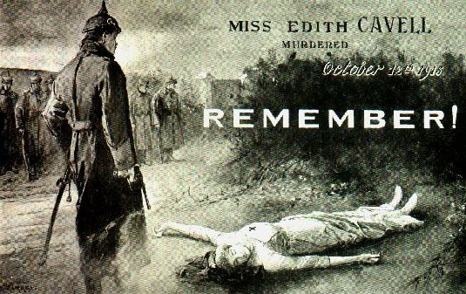

Source B

Fraternizing Between the Lines, New York Times, 30 December, 1914

LONDON – The Daily News publishes a letter from an officer in the Queen’s Westminster Rifles describing an extraordinary Christmas truce:

“…Many of our chaps walked out and met the Germans between the lines. I went over in the afternoon and was photographed in a group of English and German mixed. We exchanged souvenirs: the Germans opposite us were awfully decent fellows – Saxons, intelligent, respectable looking men. I had quite a decent talk with three or four and have two names and addresses in my note-book.
“It was the strangest scene you could imagine – going out unarmed to meet our enemies, also unarmed. After our talk I really think a lot of our newspaper reports must be horribly exaggerated. Of course, these men were Saxons – not Prussians.

Source C

Extract from Lt. Col. N. Fraser-Tytler’s Field Guns in France, (a series of letters to his father) Brighton, 1922

We had a gorgeous killing yesterday. McDonald saw 30 men go into a barn, which we had already accurately registered. We fired one salvo; one shell went right through the roof and blew out the door from the insides…We then tried the old trick of waiting for 15 minutes, which allows time for people to gather round the scene of the shelling…after which we opened fire…and fired fast for 2 minutes. One comes across only too many people who quite forget that the essence of war is to kill.

Source D

The cost of war by nation for direct war expenses to the spring of 1919

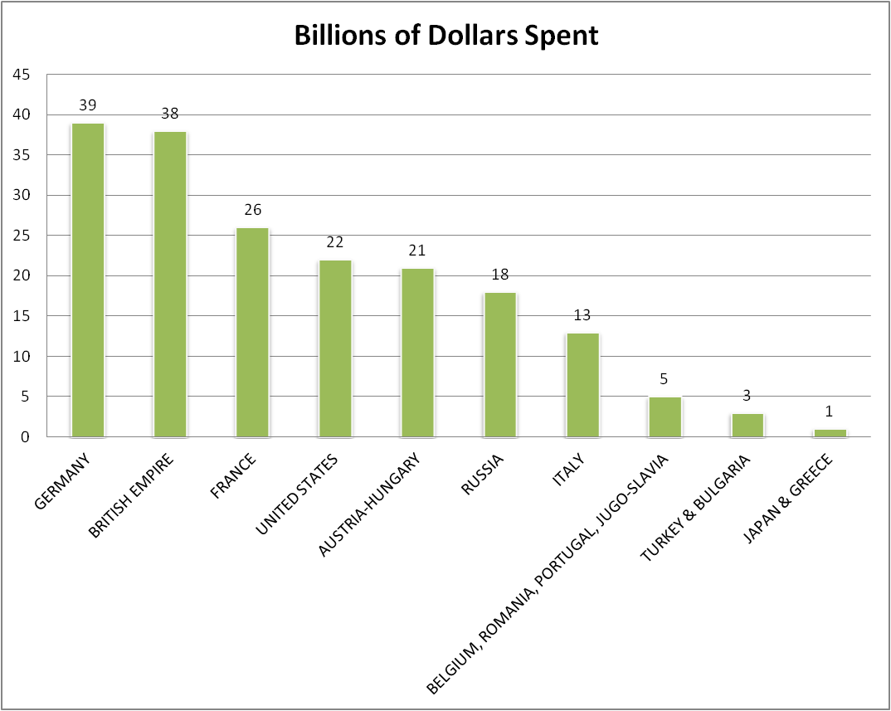
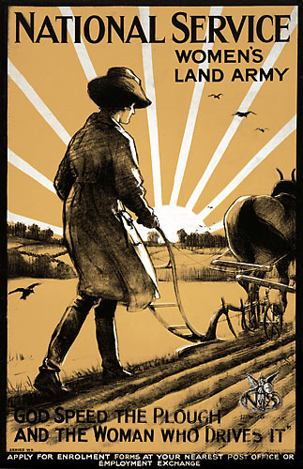
Source E

1917 British recruitment poster for the Women’s Land Army

Source F

Extract from N.P. Howard where he comments on the German Home Front in WWI

In response to the blockade before the cease-fire, German measures had ranged from all-out submarine warfare to food rationing, and the plundering* of occupied territories. These only added to the hardships of civilians. The failures of the rationing system deepened social inequalities in Germany by the end of the shooting war. It operated in favour of the rural, self-supplying population and the army and to the ultimate disadvantage of town and city consumers…A significant proportion of milk, butter and cheese and from one-third to a half of meat, eggs and fruit were distributed through the black markets at insane prices that reached up to ten-times pre-war price levels. The effects of the blockade on the poor were accentuated* by inequalities in incomes that contributed to the grossly unequal food consumption.

* plundering: robbery
* accentuated: emphasised, highlighted
‘The Social and Political Consequences of the Allied Food Blockade of Germany 1918-19’ in German History, (1993) Vol 11, Issue 2, pp162-3

2012 Modern History HSC Trial Marking Guidelines

MULTIPLE CHOICE ANSWERS
Questions
1 | 3 | 4 | 5 | 7 | 8
D | B | A | A | C | B

Question 2
Criteria | Marks
- Provides THREE reasons including at least ONE from the source | 3
- Provides TWO reasons which may or may not be from the source | 2
- Provides ONE reason which may or may not be from the source | 1

Question 6
Criteria | Marks
- Provides a clear outline with specific use of the source and use of own relevant knowledge  - Demonstrates sound knowledge of the attitudes of British and German soldiers  - Includes accurate details of the change in British and German soldiers’ attitudes towards war over time | 5-6
- Demonstrates relevant knowledge and makes reference to the source  - Makes generalisations about British and German soldiers’ attitudes to war  - May refer to change in British and German soldiers’ attitude to war | 3-4
- Demonstrates some use of own knowledge and /or source relying on simple description about British and German soldiers’ attitudes towards war | 1-2

Question 9
Criteria | Marks
- Makes a sophisticated judgement which demonstrates a thorough understanding of BOTH sources in the context of their usefulness  - Provides a comprehensive consideration of reliability and clear understanding of perspective in the context of the question | 9-10
- Makes a clear judgement about the usefulness of BOTH sources to the question but may be uneven in its treatment  - Provides a detailed consideration of reliability and clear understanding of perspective in the context of the question | 7-8
- Attempts an assessment of the usefulness of BOTH sources to the question, with some reference to perspective and reliability  OR  - Provides some consideration and evaluation of the usefulness of ONE source to the question and its perspective and reliability | 5-6
- Generalises about the usefulness of the source(s) with few links to either reliability or perspective or the question  - May paraphrase sources | 3-4
- Some reference to the use of sources generally  OR  - Simple description or paraphrase of one or both sources | 1-2
Section II — National Studies
25 marks

Questions 10–18
MARKING GUIDELINES

Criteria | Marks
- Addresses the question with a sophisticated and sustained argument, which demonstrates a comprehensive understanding of the issue(s) raised in the question  - Presents a logical, coherent and well–structured response drawing on a clear identification of relevant key features  - Supports interpretation with detailed, relevant and accurate historical information and makes use of appropriate terms and concepts | 21–25
- Addresses the question asked with a sound attempt at an argument, which demonstrates a well–developed understanding of the issue(s) raised in the question  - Presents a logical and well–structured response drawing on relevant key features  - Provides detailed, relevant and accurate historical information and makes use of appropriate terms and concepts | 16–20
- Addresses the question asked with a relevant but largely narrative or descriptive response which may contain implied understanding of the issue(s) raised in the question  - Presents a structured response, with some identification of the key features  - Provides adequate, relevant and accurate historical information incorporating some historical terms | 11–15
- Presents a narrative or descriptive response, which is largely relevant but may be generalized AND/OR incomplete  - Presents a simple response, with some identification of the key features  - Provides limited, relevant and accurate historical information incorporating some historical terms | 6–10
- Attempts a narrative or description which may be only generally relevant AND/OR seriously incomplete.  - May be disjointed AND/OR very brief  - Provides very limited historical information | 1–5

Section III — Personalities in the Twentieth Century
25 marks

Question 19(a) — 10 marks

MARKING GUIDELINES
Criteria | Marks
- Presents a detailed, ordered description of the personal background and rise to prominence of the personality  - Provides relevant and accurate historical information using a range of appropriate terms and concepts | 9–10
- Presents an ordered description of the personal background and rise to prominence of the personality  - Provides relevant and accurate historical information using appropriate terms and concepts | 7–8
- Presents a general description of the personal background and/or rise to prominence of the personality with some relevant detail  - Provides adequate and accurate historical information incorporating some historical terms | 5–6
- Presents a limited description of either the personal background or rise to prominence of the personality with simple use of historical information incorporating some historical terms | 3–4
- Presents ONE or TWO relevant facts about the twentieth century personality | 1–2

Question 18(b) — 15 marks
MARKING GUIDELINES
Criteria | Marks
- Makes a clear judgement about the statement in relation to differing historical perspectives and interpretations and the chosen personality, supported by detailed, relevant and accurate historical information  - Presents a sustained, logical and well-structured argument which effectively integrates the issues raised in the statement using a range of appropriate terms and concepts | 13–15
- Attempts a judgement about the statement in relation to differing historical perspectives and interpretations regarding the chosen personality supported by detailed, relevant and accurate historical information  - Presents a structured, logical argument which integrates the issues raised in the statement using appropriate terms and concepts | 10–12
- Addresses the question with a relevant but largely narrative, descriptive response supported by adequate and largely accurate historical information  - Presents a structured response which refers to the issues raised in the statement (may be implied) incorporating some historical terms | 7–9
- Provides a limited description of historical events related to the chosen personality  - Presents a descriptive narration which may refer to the statement incorporating some historical terms | 4–6
- Lists some historical events in the life/period of the chosen personality | 1–3

Section IV — International Studies in Peace and Conflict
25 marks
Questions 20 – 26

MARKING GUIDELINES
Criteria | Marks
- Addresses the question with a sophisticated and sustained argument, which demonstrates a comprehensive understanding of the issue(s) raised in the question  - Presents a sustained, logical and well structured response drawing on a clear identification of relevant features of the period  - Supports the response with detailed, relevant and accurate historical information  - Uses a range of appropriate historical terms and concepts | 21–25
- Addresses the question with a sound attempt at an argument, which demonstrates a well-developed understanding of the issue(s) raised in the question  - Presents a logical structured response drawing on an identification of relevant features of the period  - Provides detailed, relevant and accurate historical information  - Uses appropriate historical terms and concepts | 16–20
- Addresses the question with a relevant but largely narrative or descriptive response which may contain implied understanding of the issue(s) raised in the question  - Presents a structured response, with some identification of key features  - Provides adequate, relevant and accurate historical information  - Uses some appropriate historical terms and concepts | 11–15
- Provides a narrative or descriptive response, which is largely relevant but may be generalised AND /OR incomplete  - Presents a simple response, with some mention of relevant key features  - Provides limited, relevant historical information incorporating some historical terms | 6–10
- Attempts a narrative or description which may be only generally relevant AND/OR seriously incomplete  - May be disjointed AND/OR very brief  - Very limited use of appropriate historical terms and concepts | 1–5

Trial HSC Modern History Examination Mapping Grid
Question | Marks | Content | Syllabus outcomes
Section I — World War I 1914–1919
1, 3-5, 7-8 | 6 | World War I 1914–1919 | H3.2
2 | 3 | World War I 1914–1919 | H1.2, H3.2 , H4.2
6 | 6 | World War I 1914–1919 | H1.2, H3.2, H4.2
9 | 10 | World War I 1914–1919 | H3.3, H3.4
Section II — National Studies
10 (a) | 25 | Australia 1945–1983 | H1.2, H2.1, H4.1, H4.2
10 (b) | 25 | Australia 1945–1983 | H1.2, H2.1, H4.1, H4.2
11 (a) | 25 | China 1927–1949 | H1.2, H2.1, H4.1, H4.2
11 (b) | 25 | China 1927–1949 | H1.2, H2.1, H4.1, H4.2
12 (a) | 25 | Germany 1918–1939 | H1.2, H2.1, H4.1, H4.2
12 (b) | 25 | Germany 1918–1939 | H1.2, H2.1, H4.1, H4.2
13 (a) | 25 | India 1919–1947 | H1.2, H2.1, H4.1, H4.2
13 (b) | 25 | India 1919–1947 | H1.2, H2.1, H4.1, H4.2
14 (a) | 25 | Indonesia 1959–1998 | H1.2, H2.1, H4.1, H4.2
14 (b) | 25 | Indonesia 1959–1998 | H1.2, H2.1, H4.1, H4.2
15 (a) | 25 | Japan 1904–1937 | H1.2, H2.1, H4.1, H4.2
15 (b) | 25 | Japan 1904–1937 | H1.2, H2.1, H4.1, H4.2
16 (a) | 25 | Russia and the Soviet Union 1917–1941 | H1.2, H2.1, H4.1, H4.2
16 (b) | 25 | Russia and the Soviet Union 1917–1941 | H1.2, H2.1, H4.1, H4.2
17 (a) | 25 | South Africa 1960–1994 | H1.2, H2.1, H4.1, H4.2
17 (b) | 25 | South Africa 1960–1994 | H1.2, H2.1, H4.1, H4.2
18 (a) | 25 | USA 1919–1941 | H1.2, H2.1, H4.1, H4.2
18 (b) | 25 | USA 1919–1941 | H1.2, H2.1, H4.1, H4.2

Section III — Personalities in the Twentieth Century
19 (a) | 10 | Personalities in the Twentieth Century | H1.1, H4.1, H4.2
19 (b) | 15 | Personalities in the Twentieth Century | H1.2, H2.1, H3.4, H4.2
Section IV — International Studies in Peace and Conflict
20 (a) | 25 | Anglo-Irish Relations 1968–1998 | H1.2, H2.1, H4.1, H4.2
20 (b) | 25 | Anglo-Irish Relations 1968–1998 | H1.2, H2.1, H4.1, H4.2
21 (a) | 25 | Conflict in Europe 1935–1945 | H1.2, H2.1, H4.1, H4.2
21 (b) | 25 | Conflict in Europe 1935–1945 | H1.2, H2.1, H4.1, H4.2
22 (a) | 25 | Conflict in Indochina 1954–1979 | H1.2, H2.1, H4.1, H4.2
22 (b) | 25 | Conflict in Indochina 1954–1979 | H1.2, H2.1, H4.1, H4.2
23 (a) | 25 | Conflict in the Pacific 1937–1951 | H1.2, H2.1, H4.1, H4.2
23 (b) | 25 | Conflict in the Pacific 1937–1951 | H1.2, H2.1, H4.1, H4.2
24 (a) | 25 | Arab–Israeli Conflict 1948–1996 | H1.2, H2.1, H4.1, H4.2
24 (b) | 25 | Arab–Israeli Conflict 1948–1996 | H1.2, H2.1, H4.1, H4.2
25 (a) | 25 | The Cold War 1945–1991 | H1.2, H2.1, H4.1, H4.2
25 (b) | 25 | The Cold War 1945–1991 | H1.2, H2.1, H4.1, H4.2
26 (a) | 25 | The United Nations as Peacekeeper 1946–2001 | H1.2, H2.1, H4.1, H4.2
26 (b) | 25 | The United Nations as Peacekeeper 1946–2001 | H1.2, H2.1, H4.1, H4.2

